

College of Smart Computing

Student Name: Bhavna Saini
Roll No.: CU25260058
Specialization: Full Stack Development
Subject: Web Technology Lab
Course Code: BCFS201P
Submitted By: Bhavna Saini
Submitted To: Mr. Rizwan Hilal Shah

7th K.M. on Roorkee Haridwar Road (NH-58), Post Box No. 27, Vardhmanpuram,
Roorkee- 247667 District. Haridwar (Uttarakhand)
Website: www.coeruniversity.ac.in

Task 1 – Explore the Internet and Web (2 Marks)
Perform the following practical activities using a web browser:
- Open any website using its domain name.
- Open the same website using a different page/resource URL.
- Navigate between different web pages.
- Download any publicly available webpage/document.
- Identify whether the websites accessed use HTTP or HTTPS.
For each activity, record: Activity performed, website/URL used, HTTP or HTTPS, and a screenshot.
Expected Output: Practical observation sheet with screenshots.

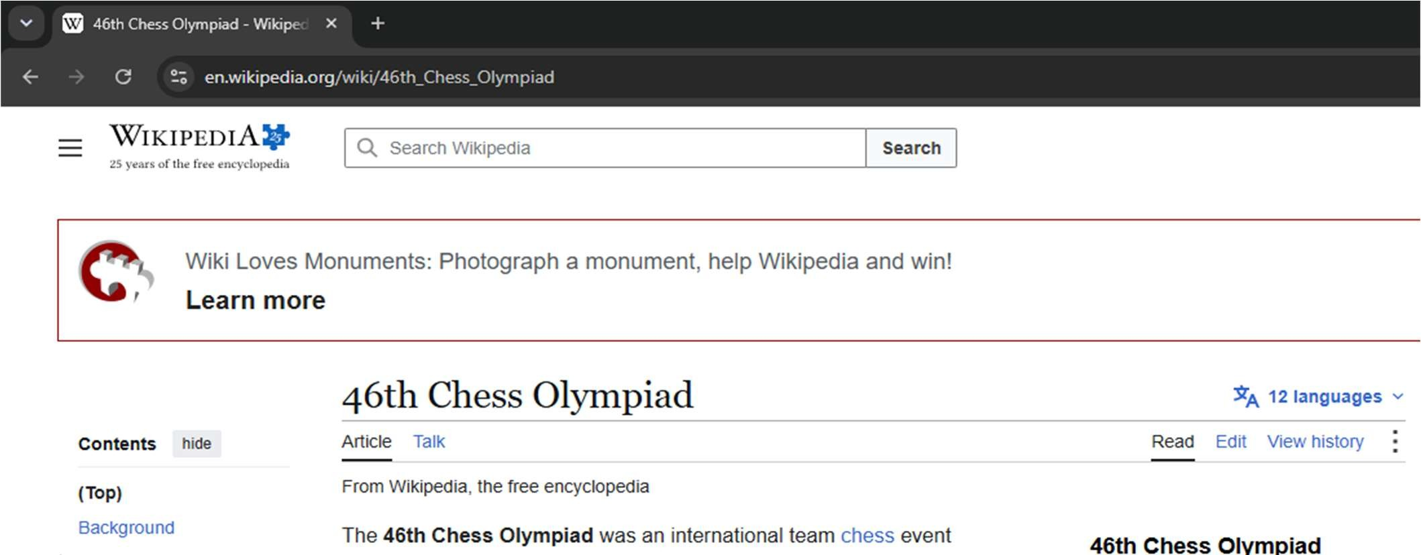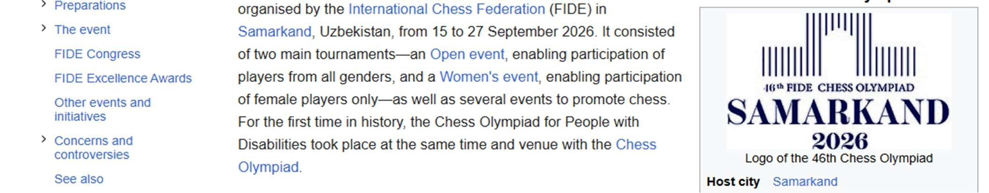
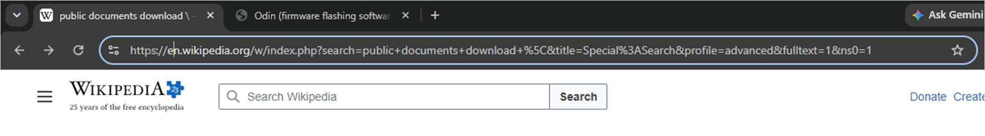
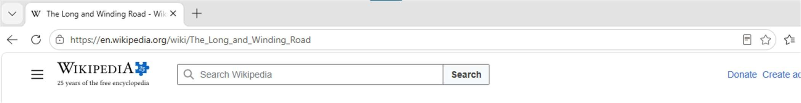
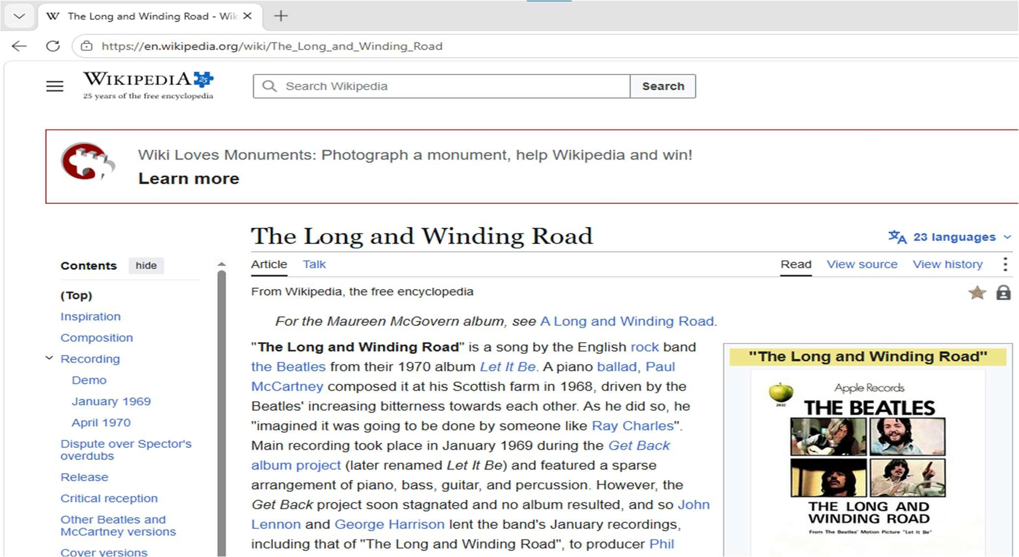

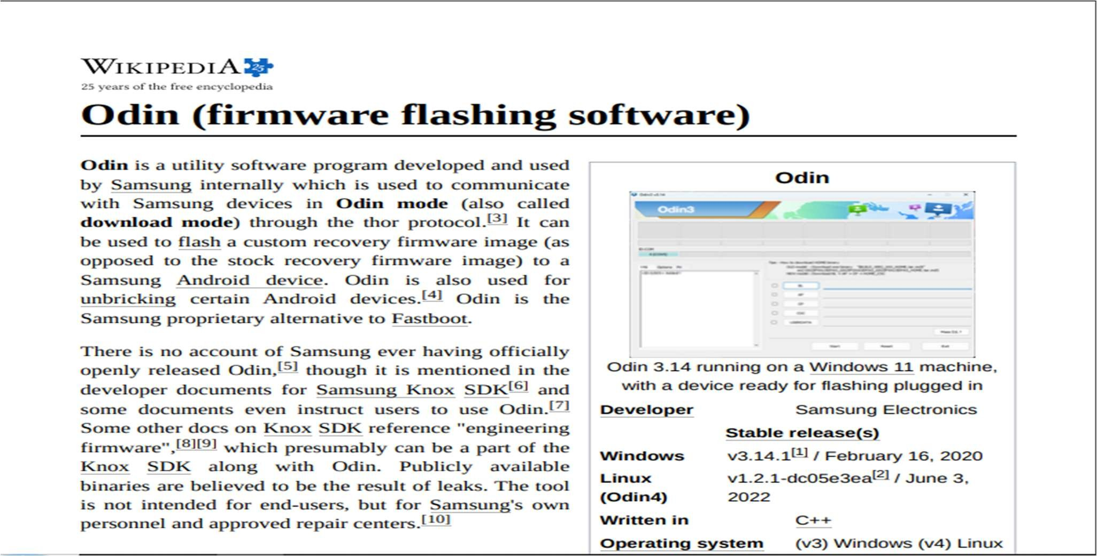

Task 2 – URL Analysis (2 Marks)
Collect five different URLs from real websites. For each URL:
- Open the URL in a browser.
- Identify the protocol.
- Identify the domain name.
- Identify the path, if present.
- Identify query parameters, if present. Example: https://www.example.com/products?id=25
Expected Output: Completed URL analysis table.

S. No. | URL | Protocol | Domain | Path | Query Parameter
1 | https://www.google.com/ | https:// | google.com | mail/u/0/#inbox | q=websites&sca
2 | https://www.wikipedia.or g/ | https:// | wikipedia.org | wiki/Main_Page | /wiki/Article
3 | https://www.youtube.com  / | https:// | youtube.com | results?search | ?search_query=short s
4 | https://www.bbc.com/new s | https:// | bbc.com/news | /technology | ?q=sports
5 | https://www.nasa.gov/ | https:// | nasa.gov | /blogs/wallops/ | ?search=events

Task 3 – HTTP/HTTPS Practical Investigation (2 Marks)
Select three websites that use HTTPS. For each website:
- Open the website in a browser.
- Observe the browser’s address bar.
- Identify the use of HTTPS.
- Click the browser’s security/site-information indicator.
- Record the security information displayed by the browser.
- Take a screenshot.
Expected Output: Three screenshots and an observation table.

Website | HTTP/HTTPS | Security Indicator | Certificate/Security Information Observed
nasa.gov | HTTPS | 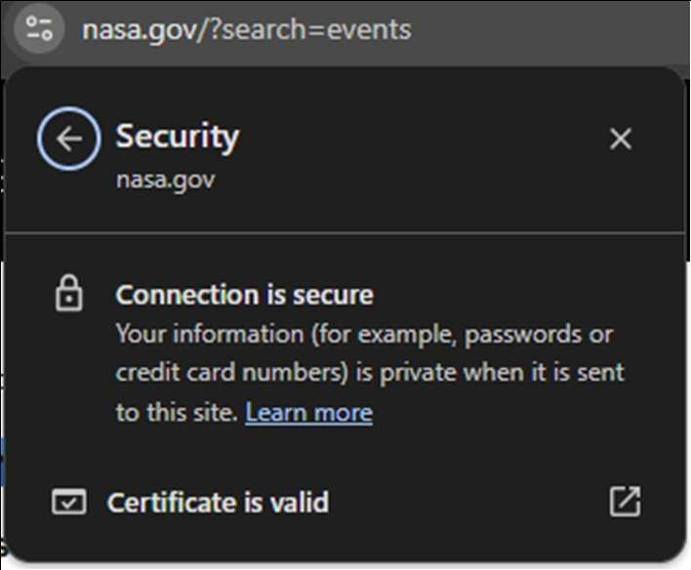 | 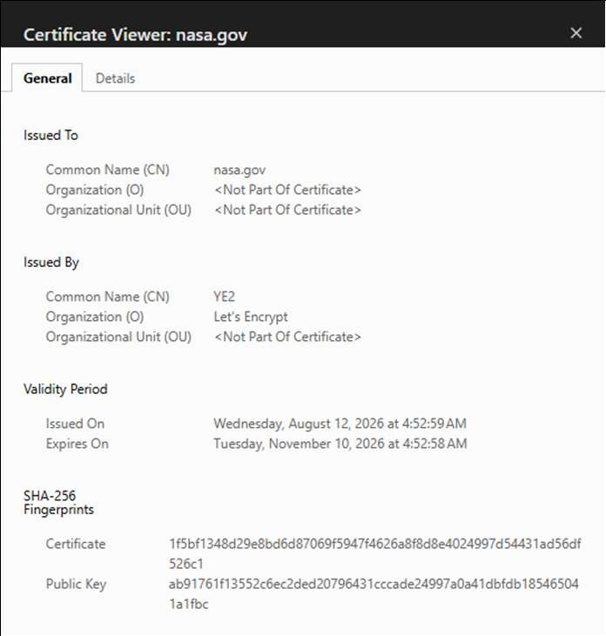
wikipedia.org | HTTPS | 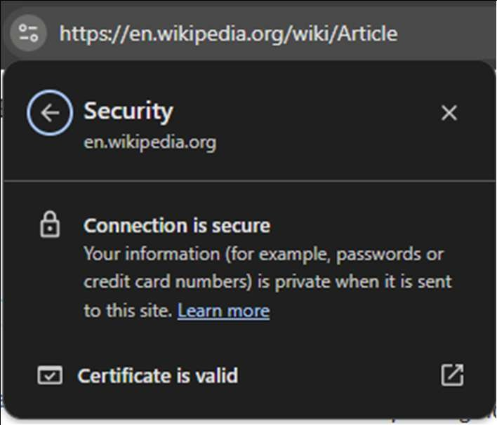 | 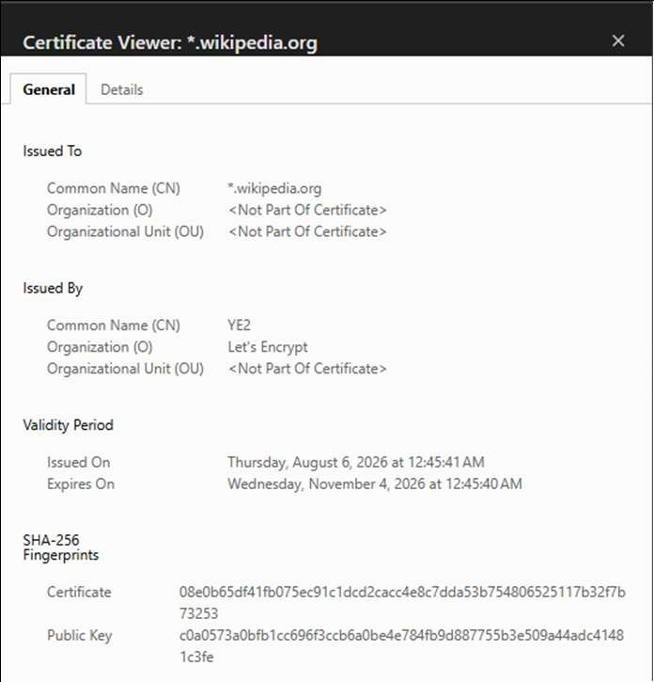
google.com | HTTPS | 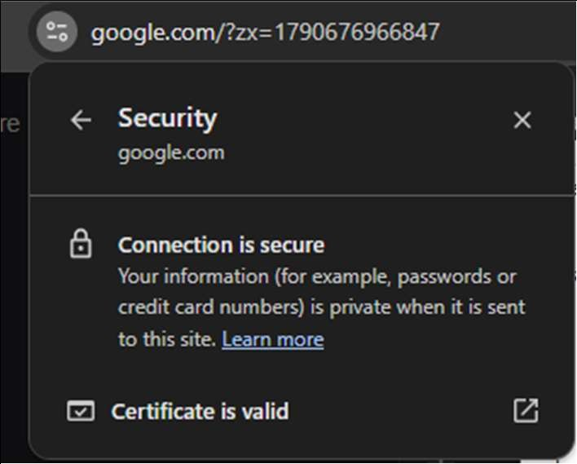 | 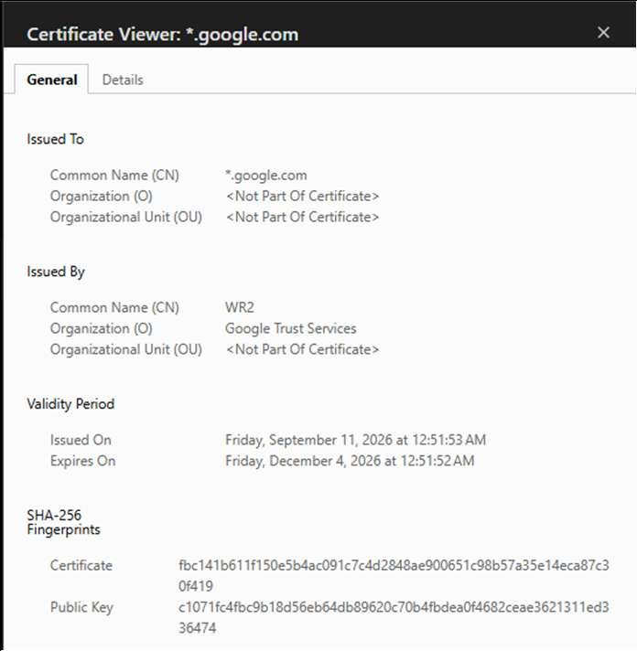

Task 4 – Create a Basic HTML Webpage (2 Marks)
Create a simple webpage on one of the following topics:
- My College
- My Department
- My City
- Internet and Its Uses
- My Favourite Technology
- About Myself
The webpage should contain:
- Page title
- At least 2 headings
- At least 3 paragraphs
- Line breaks
- Bold and italic text
- Ordered list
- Unordered list • One image • One hyperlink File name: index.html
Expected Output: Working HTML webpage opened successfully in a web browser.

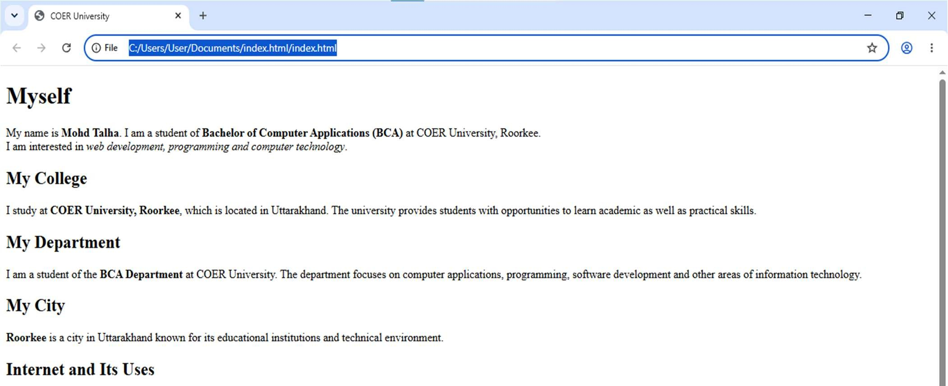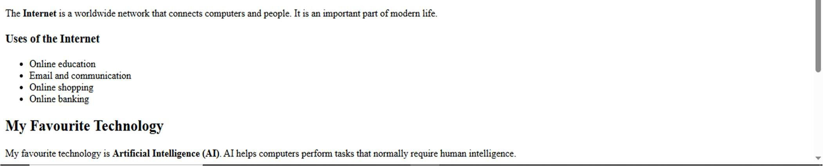

Task 5 – HTML Modification Practical (2 Mark)
Download q basic HTML file from Github. Open and modify the file according to five instructions given during the practical.
Possible modifications:
- Change the webpage title.
- Change a heading.
- Add a paragraph.
- Add/remove a list item.
- Add an image.
- Change the hyperlink.
- Add another heading.
- Modify existing text.
Expected Output: Modified HTML file and browser screenshot. Updated file must be uploaded to GitHub and supporting URL must be included in assignment

